

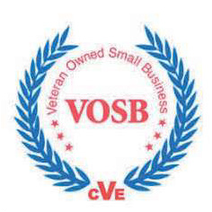CAPABILITY STATEMENT

CAGE: 0SQV5 | EUI: MZYVNN8T4B71

Specializing in administrative support, data entry, project management, and event planning. Our commitment to community empowerment is evident through our on-the-job training programs for socially challenged individuals, bridging the gap between untapped talent and professional opportunities. We foster team cohesion and community connection with innovative team-building activities and community-focused event planning. With us you not only access top-tier business solutions but also support a mission to uplift individuals and strengthen communities.

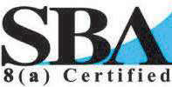

Past Performance

Hoosier Aire AdminEase Consulting Victoria’s KeyGifts

Business Formation/Establishment Website Creation

Project Management Advertising

Online Presence Boostings

Core Competencies



Diﬀerentiators

Team Building Events

Point of Contact Christina Slimp CEO (940) 252-4517

Inclusive Hiring Practices Diverse Workforce

Flexible Work Arrangements Cost-Eﬀective Solutions Activity Director Certiﬁcation

Data Entry

Project Management

[Christina.slimp@thisnthatzadmin.info](mailto:Christina.slimp@thisnthatzadmin.info)

ww.thisnthatzadmin.info

561110-Oﬃce Administrative Services 541611-Admin & General Consulting 541612-Human Resources Consulting 541613-Marketing Consulting Services 561110-Oﬃce Administrative Service 561410-Document Preparation Services